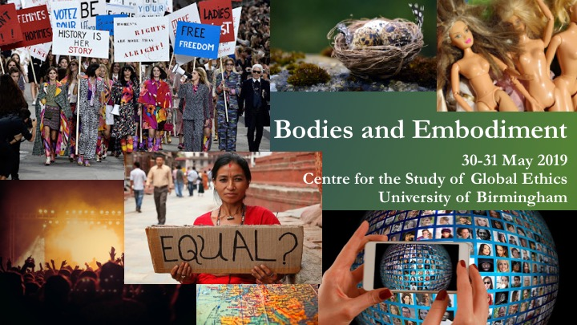

30 May 2019 – Programme Day 1

09.00 – 09.30 | Registration, coffee & tea
09.30 – 11.00 | Welcome  Keynote 1 – Claire Chambers: The normal body  Lecture Theatre 2 – Chair: Merten Reglitz
11.00 – 11.20 | Coffee & tea
11.20 – 12.35  Panel  Session A | A1: Surrogate bodies  Room: Lecture Theatre 1 – Chair: Heather Widdows  - Gulzaar Barn (King's College London): On embodied labour  - Agomoni Ganguli-Mitra (University of Edinburgh): The surrogate body as site of regulation
A2: Bodies and biomedical technologies
Room: Lecture Theatre 2 – Chair: Wouter Peeters
- Sadaf Shariat (University of South Wales): Dealing with the questions of property and intellectual property in biotechnological inventions: Alan Gewirth and the Principle of Generic Consistency
- Giovanna Sanchez Nieminen & Janika Miettinen (VTT Technical Research Centre of Finland): Impacts of digital health technologies to health equity
A3: Researched and researching bodies (1)
Room: N224 – Chair: Jonathan Parry
- Emily Postan (University of Edinburgh): The embodied research participant: interests beyond interventions
- Hayrunisa Pelge, Tonie Stolberg and Karen Guldberg (University of Birmingham): Exercising a phenomenological attitude as a way of attempting to be ethical when researching the lived experience(s) of the 'other'
A4: Female bodies in a cultural context
Room: N225 – Chair: Herjeet Marway
- Katharine Pollock (Western Sydney University): Confessing the female body in music: a discussion
- Arianne Shahvisi (Brighton and Sussex Medical School): Consenting to female genital cutting: should reinfibulation be permitted?
12.35 – 13.50 | Lunch

30 May 2019 – Programme Day 1 (continued)

13.50 – 15.05  Panel  Session B | B1: Women’s reproductive bodies (1)  Room: Lecture Theatre 1 – Chair: Herjeet Marway  - Franka Zlatic (University of Rijeka): Women's reproductive bodies  - Kate Townsend (University of Exeter): Are children's rights bad for mothers?
B2: Bodies and Artificial Intelligence
Room: Lecture Theatre 2 – Chair: Jonathan Parry
- Clint Mason (University of Birmingham): The disembodied dilemma: Is the torture of a mind absent from a body morally permissible?
B3: Researched and researching bodies (2)
Room: N224 – Chair: Jaspal Gharu
- Ájené Robinson-Burris (University of Colorado at Boulder): The standard of care debate - Whose standards? Using a Global Structural Injustice Perspective to Expose Deep-Rooted Injustice
- Omar Kaissi (University of Manchester): Professional intellectual work and body alienation in the neoliberal university
15.05 – 15.25 | Coffee & tea
15.25 – 16.40  Panel  Session C | C1: Bodies and their embodied identity  Room: Lecture Theatre 1 – Chair: Jonathan Parry  - Roxanne Burton (University of the West Indies - Barbados): Embodiment in the development of the self and personal identity  - Rebecca Howarth (University of Birmingham): The "opposite" sex: Intersexuality and the power of the body
C2: Bodies under the influence of big industries
Room: Lecture Theatre 2 – Chair: Jaspal Gharu
- Nikos Mylonas (Durham University): Fentanyl of the people: What the opioid epidemic can teach us about the suffering human body
- Ralph Early (University of Birmingham): Contested space of the human body as the embodiment of food industry profits
C3: Bodies at work
Room: N224 – Chair: Merten Reglitz
- Ben Kotzee (University of Birmingham): What's wrong with bullshit jobs
- Emma Elizabeth Partlow (University of Birmingham): Disabled bodies at work: The impacts of equalities legislation on disabled people in the workplace
C4: Bodies and the dignity of their embodied self
Room: N225 – Chair: Herjeet Marway
- Mirjam van der Heide (University of the Witwatersrand): The experience of dignity
- Sevi Emek Önder (Dokuz Eylül University - Izmir): The embodiment of the individual self: A conceptualization of body in Hegel's Phenomenology of Spirit
16.40 – 16.45 | Transfer to Education Building (directions will be provided in the conference brochure)
16.45 – 17.00 | Coffee & tea
17.00 – 18.30 | Public Lecture – Heather Widdows: My Body, My Self?  Education Building Vaughan Jefferies Lecture Theatre – Chair: Wouter Peeters
18.30 – 19.00 | Transfer to The Plough (directions will be provided in the conference brochure)
19.00 – … | Dinner and drinks

31 May 2019 – Programme Day 2

09.00 – 09.30 | Coffee & tea
09.30 – 11.00 | Notices  Keynote 2 – Tom Shakespeare: This talk is going to hurt me more than it hurts you: the problem of pain  Room: Lecture Theatre 2 – Chair: Heather Widdows
11.00 – 11.20 | Coffee & tea
11.20 – 12.35  Panel  Session D | D1: Prenatally selected bodies  Room: Lecture Theatre 1 – Chair: Merten Reglitz  - Bruce Blackshaw (University of Birmingham): Genetic selective abortion: pushing the boundaries  - Jacqueline Mae Wallis (University of Bristol): Is it ever morally permissible to select for deafness in one's child?
D2: Beyond bodies
Room: Lecture Theatre 2 – Chair: Ralph Early
- Helen Ryland (University of Birmingham): Use some body: Embodiment and morality in virtual worlds
- Brian Wong Yue Shun (University of Oxford): On Eternalism and Rights: Posthumous Rights and Rights of Future Generations
D3: Political bodies
Room: N224 – Chair: Wouter Peeters
- Anastasya Manuilova (Kommersant): Bodies under autocratic rule: a paradox of freedom
- Parish Conkling (Houston Community College): A gendered view of political violence
12.35 – 13.50 | Lunch

31 May 2019 – Programme Day 2 (continued)

13.50 – 15.40  Panel  Session E | E1: Women’s reproductive bodies (2)  Room: Lecture Theatre 1 – Chair: Heather Widdows  - Kathryn MacKay (Lancaster University): Decanting babies: What ectogenesis could mean for women's liberation  - Nipa Chauhan (University of Toronto): Beneficent paternalism: OB-GYN perspectives regarding permanent contraception for childless, single women under 30  - Nicole Miglio (San Raffaele University - Milan): Is the gestating subject "split" or "in-between"? Thinking the ambiguity of the pregnant embodiment through the immanence/transcendence dialectic
E2: Bodies in intimate relationships
Room: Lecture Theatre 2 – Chair: Merten Reglitz
- Karamvir Chadha (University of Cambridge): Sexual consent and having sex together
- Rianne Houghton (University of Birmingham): Bringing it home: How the homespace can affect women's identity in cases of domestic violence
- Jaspal Gharu (University of Birmingham): Is romantic love systematically racist?
E3: Bodies, modification and the law
Room: N224 – Chair: Ralph Early
- Luci Hyett (University of Wolverhampton): From forked tongues to Tinkerbell ears: Can biopolitics explain the apathy towards regulation of the alternative body modification industry?
- Alexander Pritchard-Jones (University of Birmingham): Body modification and consent: Prejudice in the higher courts?
- Samuel Walker (Bournemouth University): Realising A Post-Normative Legal System for a Postmodern Era?
E4: Bodies and their skin
Room: N225 – Chair: Herjeet Marway
- Mooville Theatre: LITE
- Em Walsh (McGill University): How racialization is felt on the skin: Frantz Fanon and the epidermalization of 'Inferiority'
15.40 – 16.00 | Coffee & tea
16.00 – 17.30 | Keynote 3 – Amrita Pande: Embodied Labour and the Paradox of (Re)Producing Humans  Closing remarks  Room: Lecture Theatre 2 – Chair: Jonathan Parry
17.30 – … | Drinks in The Bratby (directions will be provided in the conference brochure)

